with prize winning guests

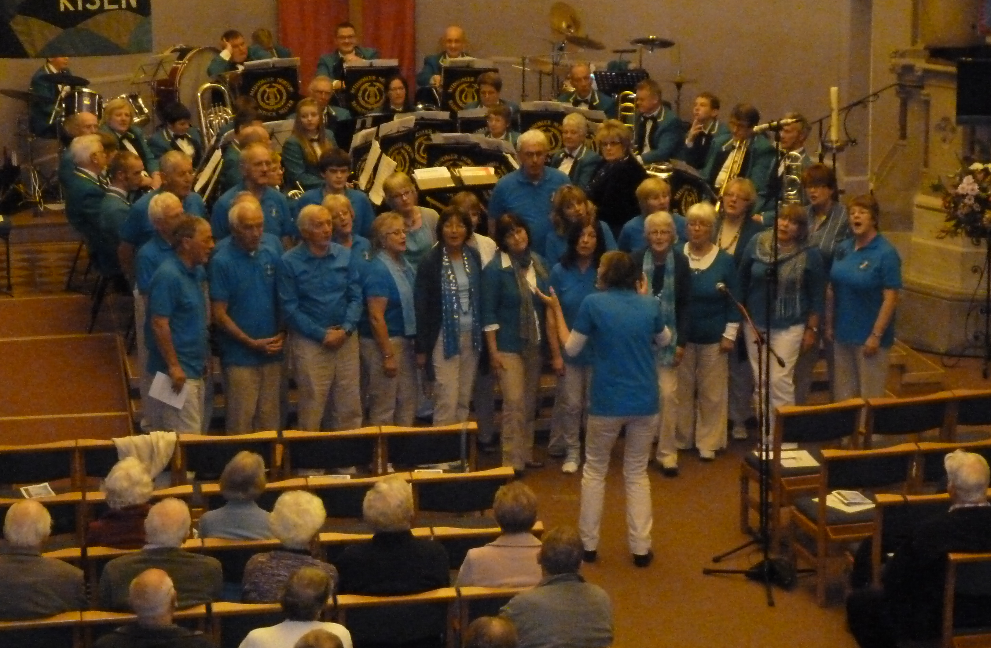

Friday 17th May

8pm

Holy Trinity Church, Nailsea

Tickets £8

from Nailsea music shop or Nailsea town council at the Tythe Barn
For further information contact 01454 411052

